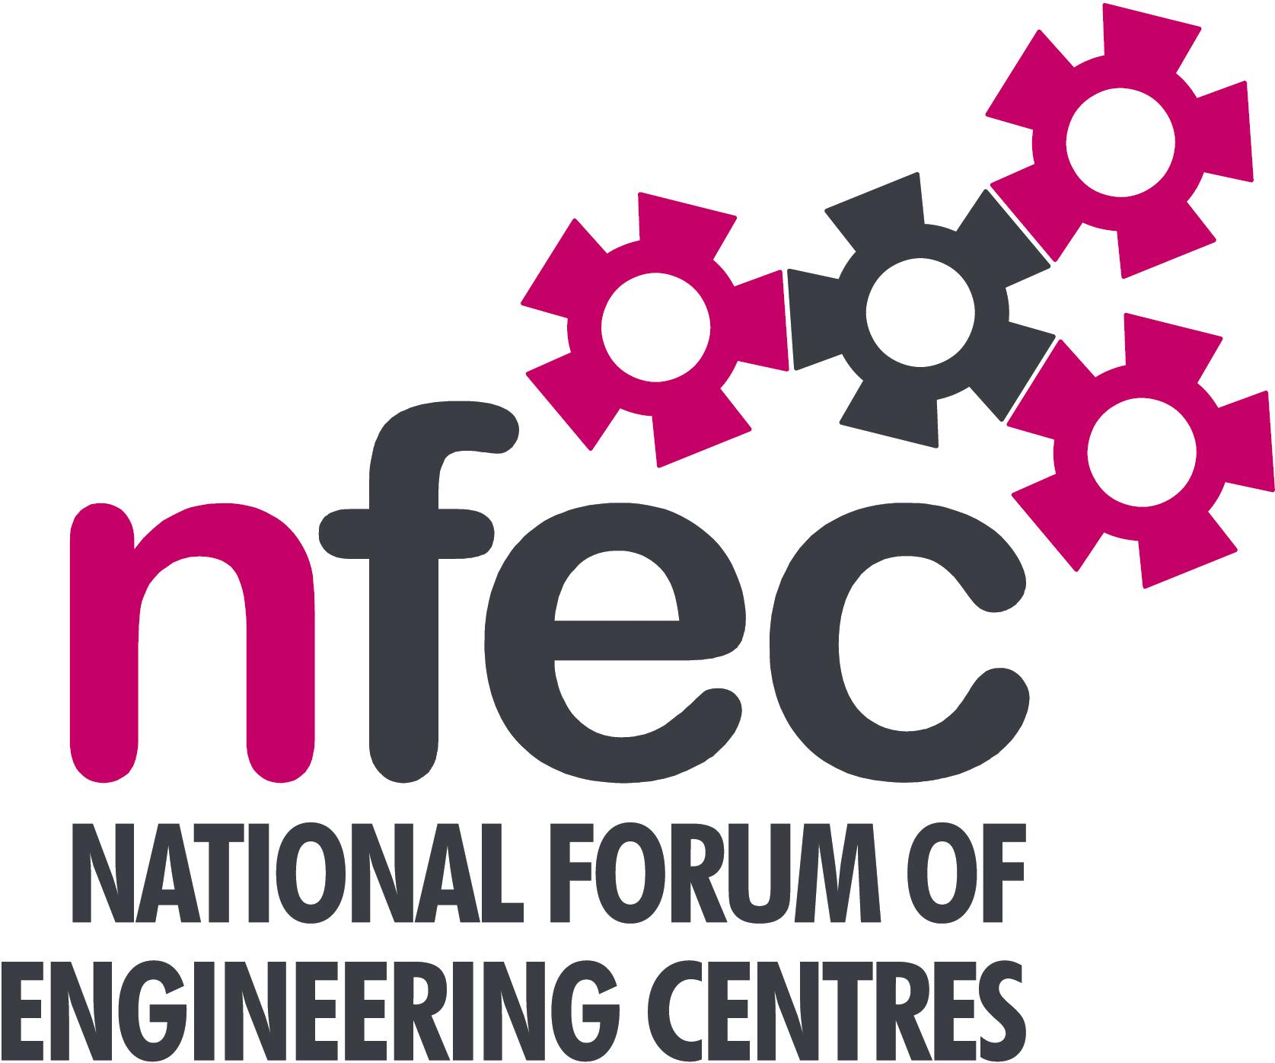
NFEC Spring 2019 North East Regional Seminar

Host: Newcastle College Rail Academy

Friday 26th April 2019, 11.00 – 14.15 (Coffee from 10.45am)
Venue: Newcastle Rail Academy, William Street, Felling, Gateshead NE10 0JP

Programme

- Welcome and Introduction to the Seminar and to the Rail Academy | John Lockey (NFEC Director and North East Regional Coordinator)  James Edge, Newcastle College Rail Academy | 11.00
- Current matters of concern relating to quality, content, structure, management and delivery of programmes of training and education in Engineering (not included on Agenda) - an opportunity for open discussion with a focus to distill key issues and plans for addressing them, e.g. FE, HE, Higher and Degree level apprenticeships, funding…..  - T Levels - Update on T Level Developments and related issues – feedback from the Manufacturing and Processing group on T level developments. Followed by open discussion.  - Qualifications and Awarding Bodies – Current developments and general issues.  Lunch and Demonstrations by Exhibitors  - NFEC and IMechE Design Competition  Tour of facilities at the Rail Academy  - Plenary session – Issues to note and agreed actions for NFEC  - Date, Place and Topics for next Seminar  Close  Entry is free to this seminar for members or non-members present for a first attendance.There will be a charge for non members after this for attending future seminars. A light buffet lunch will be provided and you will be able to see/discuss demonstrations of the latest available equipment and facilities for the delivery of learning in Engineering. | All Delegates/John Lockey  Peter Winebloom, Panel Chair, Manufacturing and Processing  Pearson – Simon Bowker  Maybe OCR – Martin Webber  Bowman Bradley, IMechE and John Lockey  All Delegates/John Lockey  To book your place: Email: admin@nfec.org.uk  Phone: 07759 901229 | 11.05  11.15  12.10  12.30  13.15  13.35

